**Overview**

AWS is growing too quickly these days and it has a lot of services for business and personal use. Today, I'm going to discuss one of the AWS services which is known as **Amazon Lex**, with this I have created one cute bot named as **WeatherBot**. It shows the weather information from all around the world. Not only that, **openweathermap API** also helps me to complete this project. You can ask directly to this bot about your city’s weather or you can simply put your location after few conversations. Too many queries are set in this bot for user processing like, weather in {City}, show weather near me, I'm in {City}, show the weather detail, check weather in {City}, please show weather near me, I'm in {City}, etc. I have chosen the most popular and my favorite programming language (Framework) **NodeJS 12** to create this bot, it is easy and powerful script.

***(I have created lambda from both python and NodeJS but here I will only describe NodeJS)***

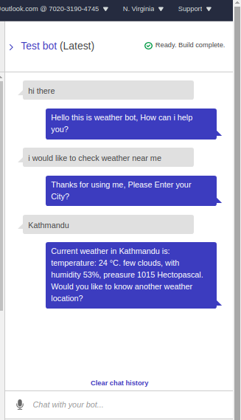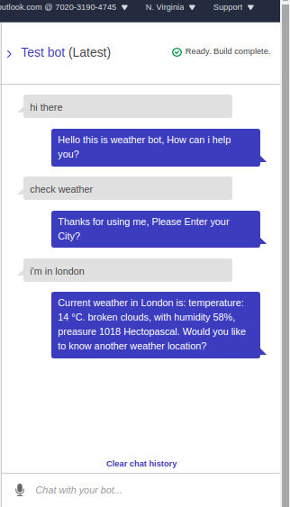

**Method of Creating Bot in Amazon Lex**

First, I login in **console.aws** and searching for Lex service, after that I clicked on create button and doing some simple custom setting. Name as **WeatherBot**, Language as **English-US**, Voice as **Salli**, Timeout **5 min**, and Sentiment as **Yes**. After that I created two intents named as **introd** and **CityWeather** and slots as needed.

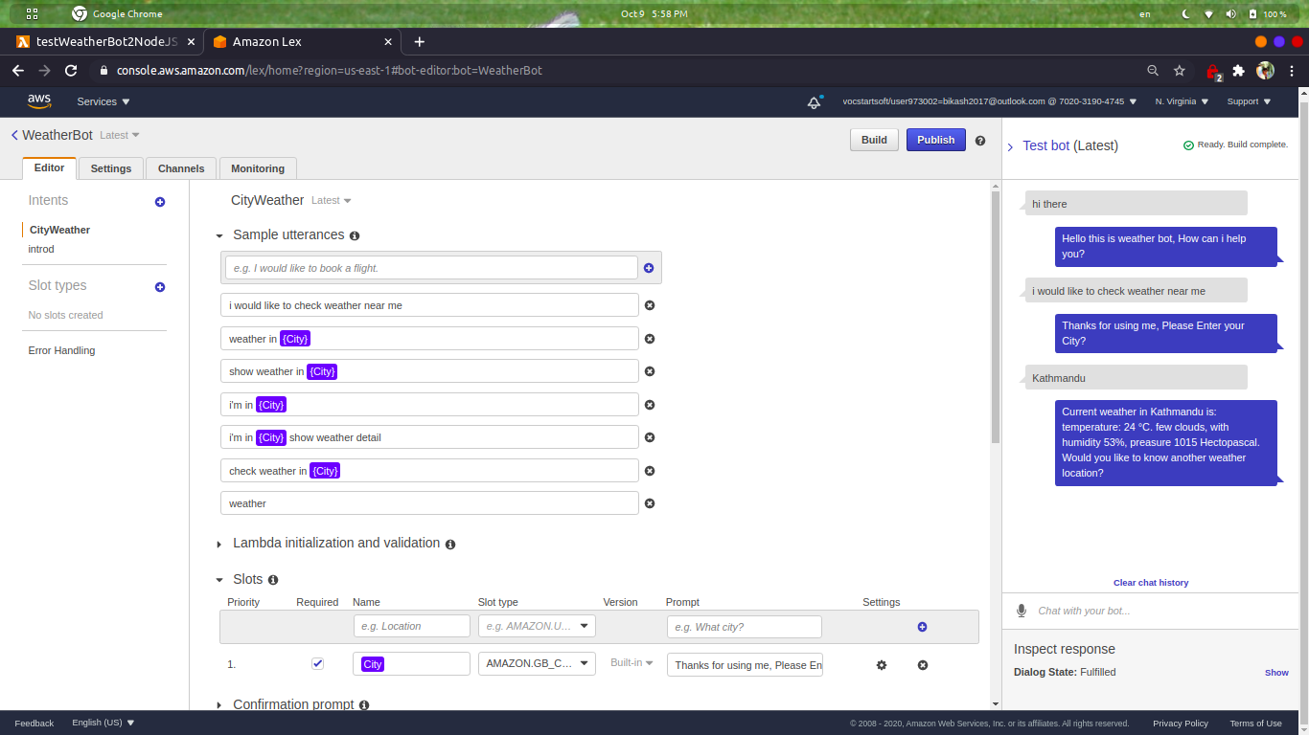

Similarly, I created Lambda function named as **teseWeatherBot2NodeJS** from lambda service with default settings. And finally I implement lambda in lex and some Response also for better conversations. *(I set lambda timeout to 1 min)*

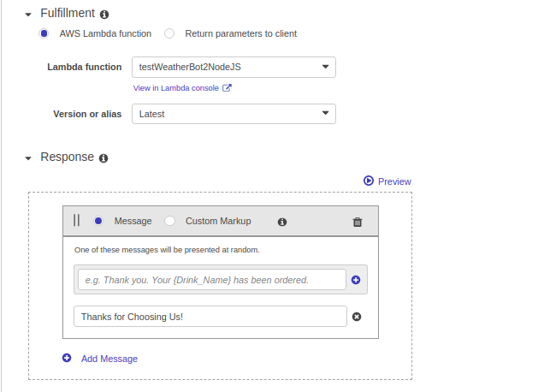

**Code Review**

I have import http for web access and phasing the user input in lambda by using *event.currentIntent.slots["City"]* code. And then I created account in openweathermap and produce API key which is needed to get data. The next process is to add the user’s city in API URL and I completed this process by using ‘+’ sign in middle. And the process is completed with making of variables.

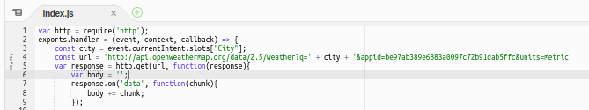

After that I used to loop, if one intent is completed then goes to next intent by using if, else method. Where I used **slotToElicit** as type and calling the intent name **CityWeather** where I created in Amazon Lex.

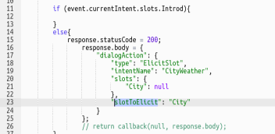

And finally, the main method to display the weather detail which user want, here I used **Close** as Type, **Fulfilled** as fullfillmentState and output in **content.** Below I attached the image file of code for your understanding:

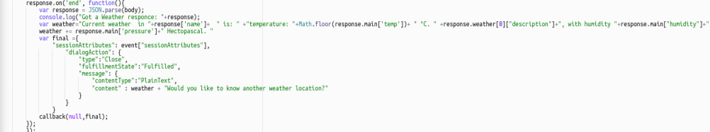

**One Small request for you sir, I have created web but unable to implement bot, I want to use this Bot in real application, please provide the access for certain time to implement bot in real application. I'm working on that project; I have uploaded all cities on DynamoDb for user validation and still working on lambda function (tried to implement one lambda into another).**

**This is just a demo bot but want to created perfect bot with all validation, I will show you after completed (need IAM permission), I'm sure that, this project makes you happy.**